SQL TEST

Question 1

SELECT TOP 5
c.CustomerID,
c.Name AS CustomerName,
SUM(so.TotalAmount) AS TotalSpent
FROM customer c
JOIN salesorder so
ON c.CustomerID = so.CustomerID
GROUP BY c.CustomerID, c.Name
ORDER BY TotalSpent DESC;

Answer ;

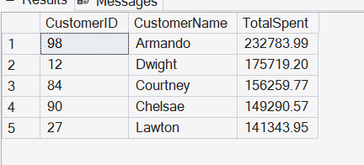

Question 2

SELECT
s.SupplierID,
s.Name AS SupplierName,
COUNT(DISTINCT pod.ProductID) AS Product_Count
FROM supplier s
JOIN purchaseorder po
ON s.SupplierID = po.SupplierID
JOIN purchaseorderdetail pod
ON po.OrderID = pod.OrderID
GROUP BY s.SupplierID , s.Name
HAVING COUNT(DISTINCT pod.ProductID) > 10;

Answer ;

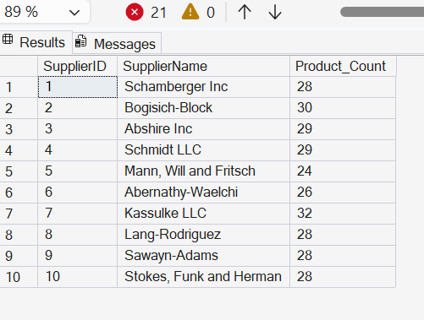

Question 3 ;

SELECT p.ProductID, p.Name AS productname , sum(sod.Quantity) as total_order_quantity
FROM [product] p
JOIN salesorderdetail sod
ON p.ProductID = sod.ProductID
Join returndetail rd
ON sod.ProductID = rd.ProductID
WHERE rd.ProductID is NULL
GROUP BY p.productID , p.NAme;

Answer ;

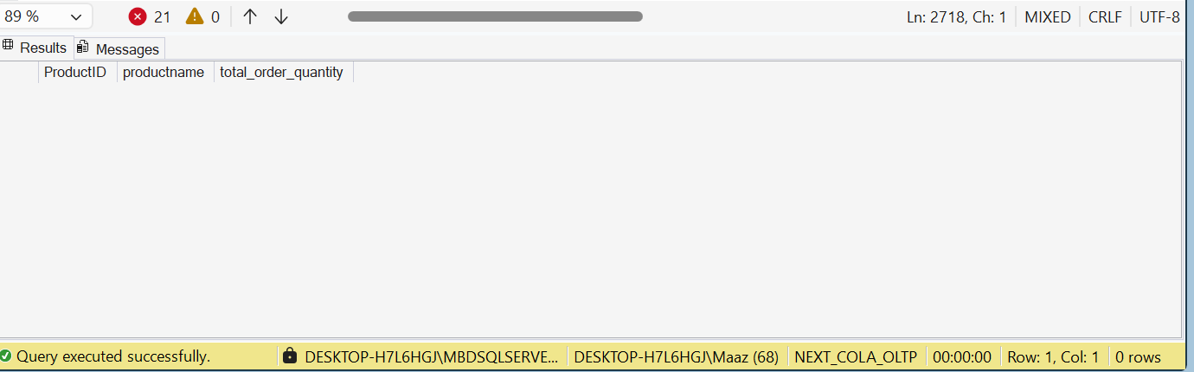

Question 4 :

SELECT c.CategoryId , c.Name AS CategoryName , p.Name AS ProductName , p.Price AS ProductPrice
FROM category c
JOIN [product] p
ON c.CategoryID = p.CategoryID
WHERE p.Price =
(
SELECT MAX(pp.Price)
FROM product pp
WHERE pp.CategoryID = p.CategoryID
);

Answer :

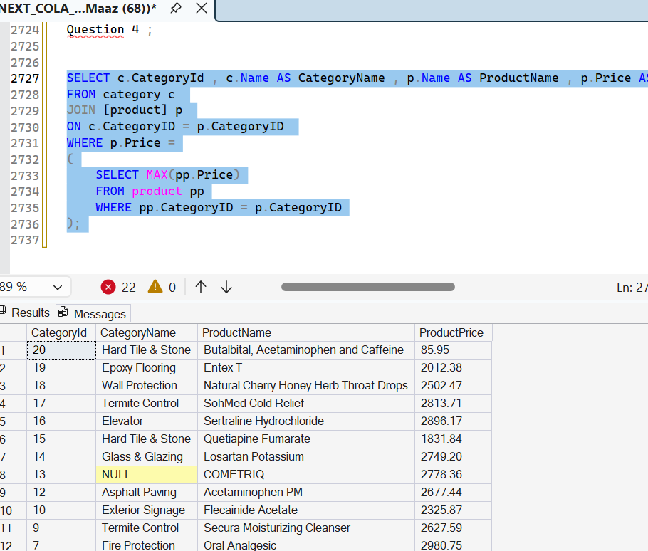

Question 5 :

SELECT
so.OrderID, c.Name AS CustomerName,p.Name AS ProductName,cat.Name AS CategoryName,sup.Name AS SupplierName,sod.Quantity
FROM salesorder so
JOIN customer c
ON so.CustomerID = c.CustomerID
JOIN salesorderdetail sod
ON so.OrderID = sod.OrderID
JOIN product p
ON sod.ProductID = p.ProductID
JOIN category cat
ON p.CategoryID = cat.CategoryID
JOIN purchaseorderdetail pod
ON p.ProductID = pod.ProductID
JOIN purchaseorder po
ON pod.OrderID = po.OrderID
JOIN supplier sup
ON po.SupplierID = sup.SupplierID
ORDER BY OrderID;

Answer :
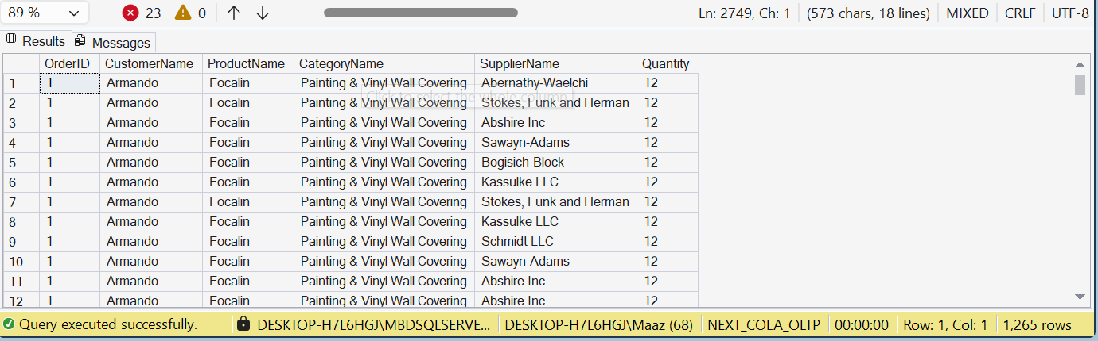

Question 6 :

SELECT
s.ShipmentID,
l.Name AS WarehouseName,
e.Name AS ManagerName,
p.Name AS ProductName,
sd.Quantity AS QuantityShipped,
s.TrackingNumber
FROM shipment s
JOIN warehouse w
ON s.WarehouseID = w.WarehouseID
JOIN location l
ON w.LocationID = l.LocationID
JOIN employee e
ON w.ManagerID = e.EmployeeID
JOIN shipmentdetail sd
ON s.ShipmentID = sd.ShipmentID
JOIN product p
ON sd.ProductID = p.ProductID;

Answer :

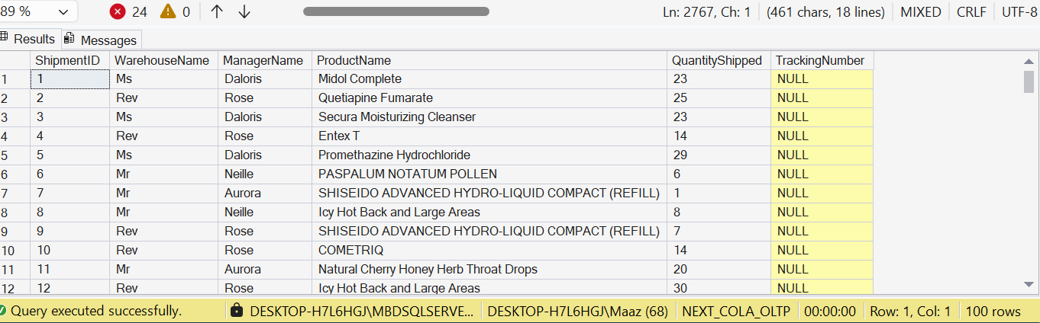

Question 7 :

WITH RankedOrders AS
(
SELECT
c.CustomerID,
c.Name AS CustomerName,
so.OrderID,
so.TotalAmount,
RANK() OVER
(
PARTITION BY c.CustomerID
ORDER BY so.TotalAmount DESC
) AS OrderRank
FROM customer c
JOIN salesorder so
ON c.CustomerID = so.CustomerID
)
SELECT
CustomerID,
CustomerName,
OrderID,
TotalAmount
FROM RankedOrders
WHERE OrderRank <= 3;

Answer :

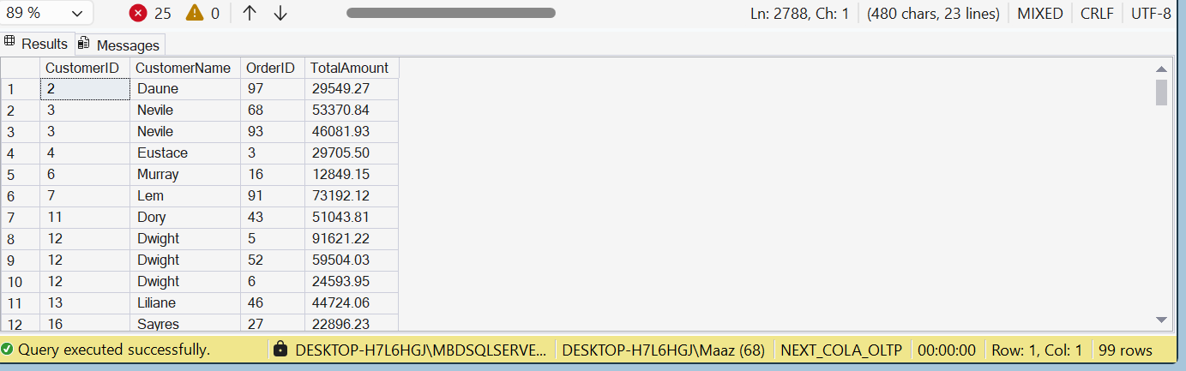

Question 9 :

CREATE VIEW vw_CustomerOrderSummary
AS
SELECT
c.CustomerID,
c.Name AS CustomerName,
COUNT(so.OrderID) AS TotalOrders,
SUM(so.TotalAmount) AS TotalAmountSpent,
MAX(so.OrderDate) AS LastOrderDate
FROM customer c
LEFT JOIN salesorder so
ON c.CustomerID = so.CustomerID
GROUP BY c.CustomerID, c.Name;

SELECT * FROM vw_CustomerOrderSummary

Answer :
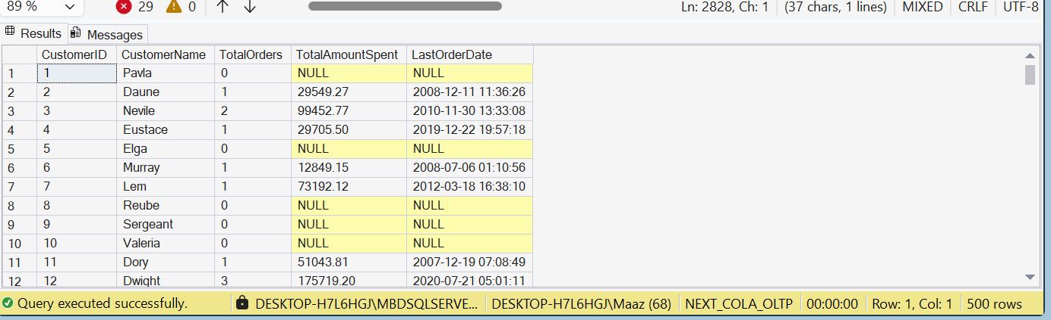

Question 10 :

CREATE PROCEDURE sp_GetSupplierSales
@SupplierID INT
AS
BEGIN
SELECT
@SupplierID AS SupplierID,
SUM(sod.TotalAmount) AS TotalSalesAmount
FROM supplier s
JOIN purchaseorder po
ON s.SupplierID = po.SupplierID
JOIN purchaseorderdetail pod
ON po.OrderID = pod.OrderID
JOIN salesorderdetail sod
ON pod.ProductID = sod.ProductID
WHERE s.SupplierID = @SupplierID;;
END;

EXEC sp_GetSupplierSales @SupplierID=1;

Answer :

